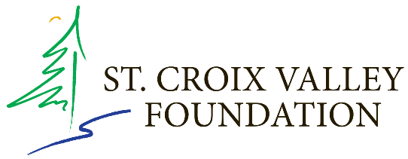

VALLEY ARTS INTIATIVE
COMPETITIVE GRANT PROGRAM – 2020-2021

Overview and Eligibility
The Valley Arts Initiative is a grant program designed to support the activities of local arts organizations. Each year the SCVF receives a Wisconsin Arts Board award and matches this award with funds from foundations and individual donors.

To be eligible, the applicant must be a nonprofit 501(c)(3) arts organization located in the St. Croix Valley (Washington and Chisago counties in Minnesota and Pierce, Polk, Burnett and St. Croix counties in Wisconsin). Applicants may also designate a 501(c)(3) organization as a fiscal sponsor. Applicants must also have no outstanding final reports due to the SCVF for previous arts grants.

Funding Categories
In 2020, due to COVID-19, the Valley Arts Initiative grant program will fund general operating expenses for arts organizations in our six-county service area.
Funding Criteria
The Foundation reviews proposals using the following criteria:
- Organizational Excellence and Leadership
- Community Benefit
- Management and Fiscal Responsibility

The review panel will make an effort to ensure available funds are awarded to organizations throughout our service area.

Eligible Expenses
Grant funds must be expended within one year from the date of the award.

Grant Range
Grants range from $500 up to $10,000. Proposals may be awarded partial funding.

Proposal Limits
An organization is limited to one proposal for each SCVF grant program, including the Valley Arts Initiative. An applicant may submit a proposal for a different SCVF grant program during the same grant cycle if they are eligible.

Decision-Making Process
A panel reviews proposals in a public meeting. Applicants are invited and encouraged to attend, but attendance will not affect the decision on your organization’s proposal. Decisions in all grant programs follow an established review process and are made according to a conflict of interest policy.

Questions: Contact Angie Pilgrim, Grants and Programs Officer, St. Croix Valley Foundation, 715-386-9490

